
x
Company
Logotype

Cone Beam Computed Tomography- Report



Porur Dental X-rays & CBCT

Patient Name : Mrs. Parvathy | Date of Report : 16.07.2024
Age/ Gender : 61 years/ Female | Region of Interest : CBCT Sectional – maxilla and mandible
Referring doctor: Dr. M. Jasmine Crena | Indication : Implant assessment
Clinical Notes: Nil
PATIENT INFORMATION

CBCT- Sectional – maxilla and mandible provided
CBCT – IMAGE DETAILS

RADIOGRAPHIC INTERPRETATION

- Completely missing crown and root in relation to 24, 25, 26, 27, 28, 36, 37, 38.
- Crown in relation to 21, 22, 23
- The maxillary and mandibular alveolar bone is present with normal underlying trabecular pattern.

IMPLANT ASSESSMENT

 | 24 region | 25 region | 26 region
Sub-Crestal | 4.37 | 4.17 | 4.24
Mid- Crestal | 4.5 | 4.97 | 5.95
Distance between the alveolar ridge and Floor of the Nasal cavity (in mm) | 13.76 | - | -
Distance between the alveolar ridge and Floor of the maxillary sinus (in mm) | - | 12.45 | 4.46
Bone type | D3 | D3 | D3

 | 36 region | 37 region
Sub-Crestal (in mm) | 4.58 | 6.61
Mid- Crestal (in mm) | 6.64 | 7.43
Distance between alveolar ridge and the inferior alveolar nerve canal (in mm) | 8.35 | 8.09
Distance between the alveolar ridge and lower border of mandible (in mm) | 17.85 | 17.75
Bone type | D2 | D2

RADIOGRAPHIC IMPRESSION

- Partially edentulous maxillary and mandibular arch.
- Crown: 21, 22, 23

Kindly correlate with clinical findings


IMAGES FOR REFERENCE

RECONSTRUCTED PANORAMIC VIEW

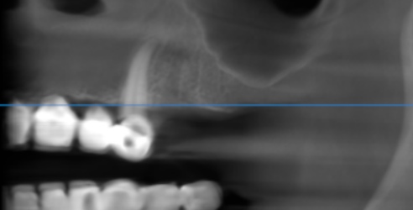

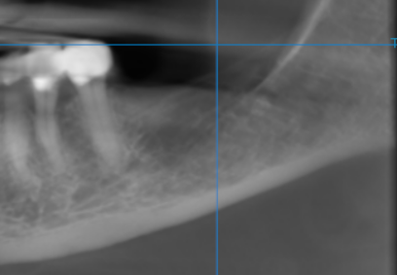

3-DIMENSIONAL VIEW

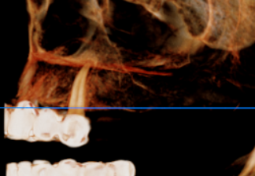

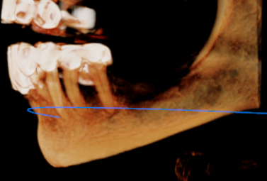

CROSS SECTIONAL VIEW

24 region | 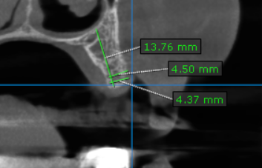
25 region | 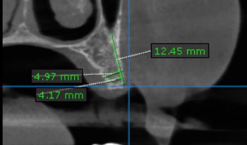
26 region | 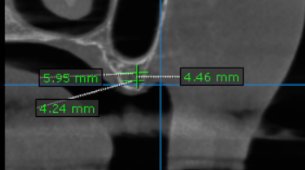
36 region | 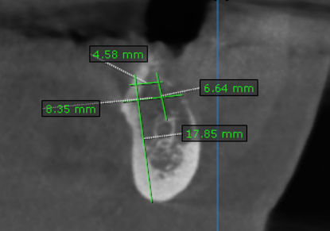
37 region | 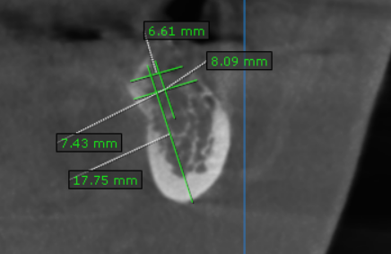

REFERENCE

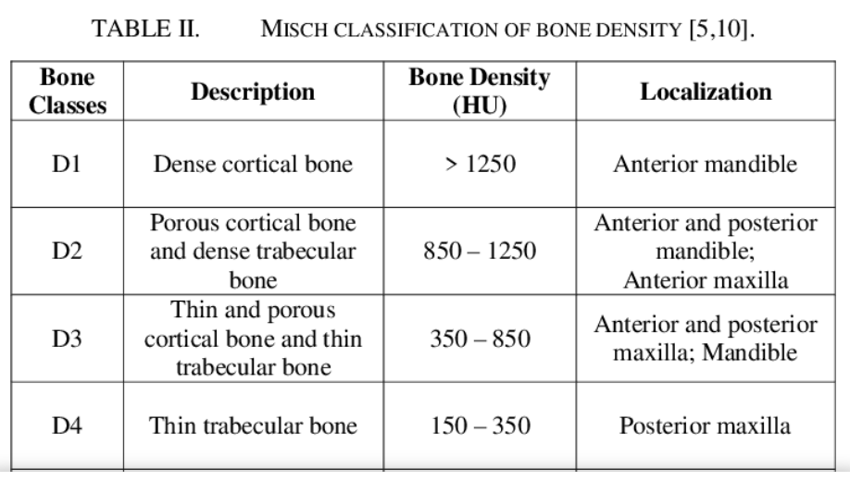

**** End of report ****

